Name: ______________________________________ Date: ________________________

Student Exploration: Photosynthesis Lab

Vocabulary: carbon dioxide, chlorophyll, glucose, limiting factor, nanometer, photosynthesis, wavelength

Prior Knowledge Questions (Do these BEFORE using the Gizmo.)

- To survive, what gas do we need to breathe in? ___________________________________

- Where is this gas produced? __________________________________________________

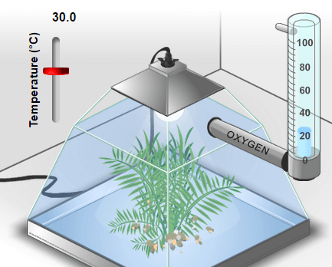

Gizmo Warm-up
During photosynthesis, plants use the energy of light to produce glucose (C₆H₁₂O₆) from carbon dioxide (CO₂), and water (H₂O). Glucose is a simple sugar that plants use for energy and as a building block for larger molecules.

A by-product of photosynthesis is oxygen. Plants use some of the oxygen they produce, but most of it is released. In the Photosynthesis Lab Gizmo, you can monitor the rate of photosynthesis by measuring oxygen production.

- Observe the left pane closely. What do you think the bubbles are? ____________________

- Select the BAR CHART tab. On the graph, notice the Oxygen production bar. Move the Light intensity slider back and forth. How does light intensity affect oxygen production?

_________________________________________________________________________

- Experiment with the vertical Temperature slider (upper left) and the CO₂ level slider.

  - How does temperature affect oxygen production? ___________________________

___________________________________________________________________

  - How does CO₂ level affect oxygen production? ______________________________

___________________________________________________________________

  - How does oxygen production relate to the rate of photosynthesis? ______________

___________________________________________________________________
Activity A:  Ideal conditions | Get the Gizmo ready:  - Be sure that the BAR CHART tab is selected.  - Turn on Show numerical values. | 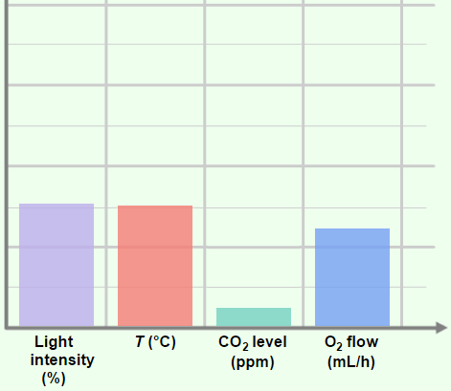

Question: In the Gizmo, what are the ideal conditions for photosynthesis?

- Form hypothesis: During photosynthesis, light energy is used to synthesize carbon dioxide (CO₂) and water (H₂O) into glucose (C₆H₁₂O₆) and oxygen (O₂). The complex series of chemical reactions is summarized by the following formula:

6CO₂ + 6H₂O + light energy C₆H₁₂O₆ + 6O₂

In the Gizmo, what light intensity and CO₂ level do you think will maximize the rate of photosynthesis? ___________________________________________________________

- Experiment: Use the Gizmo to find the ideal conditions for photosynthesis. Use any method you like. When you think you have the answer, list the conditions below.

Temperature | Light intensity | CO₂ level | Oxygen production

- Revise and repeat: One way to test if you’ve found the ideal conditions is to change each variable slightly from the value that you recorded above. If the oxygen production decreases with each change that you make, it is likely you have found the ideal conditions. If a small change causes oxygen production to increase, continue to experiment.

If necessary, revise your numbers in the table above.

- Think and discuss: Think about the process of finding the ideal conditions.

    - Why would it be hard to find the ideal light intensity if the temperature were very hot or cold? ____________________________________________________________
___________________________________________________________________

    - Why would it be hard to find the ideal CO₂ level if the light intensity were very low? ___________________________________________________________________
___________________________________________________________________

Activity B:  Colored light | Get the Gizmo ready:  - Select the COLOR tab and the BAR CHART tab.  - Set the Temperature to 24°C, the Light intensity to 90%, and the CO₂ level to 1,000 ppm. | 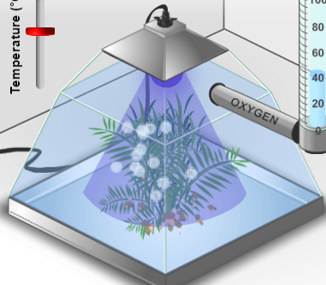

Introduction: Plants use a green pigment called chlorophyll to absorb light and convert its energy into a form that the plant can use. Chlorophyll gives plants their green color.

Question: What color of light is the best for photosynthesis?

- Observe: The color of a light wave is determined by its wavelength. On the COLOR tab, slowly drag the Light wavelength slider back and forth and observe the effect on oxygen production. How does the color of light affect the rate of photosynthesis?

_________________________________________________________________________

_________________________________________________________________________

- Form hypothesis: Which color of light do you think will maximize the rate of photosynthesis?

_________________________________________________________________________

- Gather data: Set the Light wavelength to 400 nm. (The symbol “nm” stands for nanometers. A nanometer is a billionth of a meter.) Visible light ranges from 400 to 700 nm.

On the TABLE tab, click Record data. Then set the Light wavelength to 420 nm, and repeat. Continue recording data in the Gizmo every 20 nm until the wavelength is 700 nm.
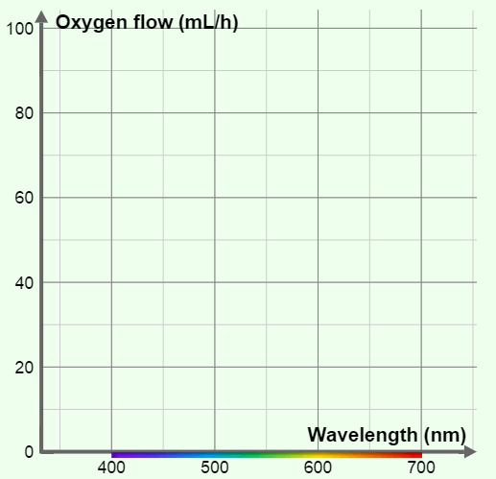

- Make a graph: Select the GRAPH tab and select Wavelength. Sketch the graph in the space at right.

    - Which colors were absorbed best by the plant? ______________________________

    - Which colors were absorbed worst?

____________________________________

- Think and discuss: When we look at a leaf, we see the colors of light that are reflected off its surface. How does this explain the relatively low flow of oxygen in green light?

_________________________________________________________________________

_________________________________________________________________________

Extension:  Limiting factors | Get the Gizmo ready:  - Select the WHITE tab and the BAR CHART tab.  - Turn on Show numerical values. | 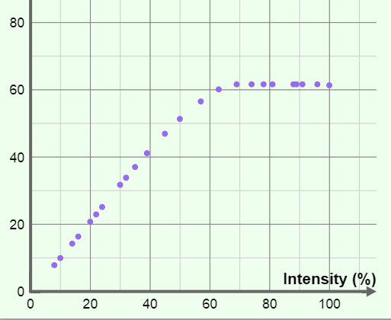

Introduction: Photosynthesis requires light, water, and CO₂ to work. When one of these factors is in short supply, it is called a limiting factor. Temperature can also be a limiting factor when it is too hot or too cold for photosynthesis to work well.

Question: What is the effect of limiting factors on photosynthesis?

- Observe: Set Temperature to 24°C, Light intensity to 50%, and CO₂ level to 200 ppm.

- Move the Temperature slider up and down. Were you able to increase oxygen production? _____________________ (Return the slider to 24°C when finished.)
- Move the Light intensity slider back and forth. Were you able to increase oxygen production? _____________________ (Return the slider to 50% when finished.)
- Move the CO₂ level slider back and forth. Were you able to increase oxygen production? _____________________ (Return the slider to 200 ppm when finished.)

- Analyze: In this situation, what was the limiting factor? _____________________________

How do you know? _________________________________________________________

_________________________________________________________________________

- Challenge: In each of the situations below, use the Gizmo to find the limiting factor.

Temperature | Light intensity | CO₂ level | Limiting factor
25°C | 60% | 700 ppm
15°C | 20% | 200 ppm
30°C | 50% | 400 ppm

- Think and discuss: Suppose you were a farmer trying to grow plants in a greenhouse. Why would it be important to know what the limiting factor is?

_________________________________________________________________________

Student Exploration: Cell Energy Cycle

Vocabulary: aerobic, anaerobic, ATP, cellular respiration, chemical energy, chlorophyll, chloroplast, cytoplasm, glucose, glycolysis, mitochondria, photosynthesis, radiant energy

Prior Knowledge Questions (Do these BEFORE using the Gizmo.)

- What does a plant need to survive and grow? ____________________________________

_________________________________________________________________________

- What does an animal need to survive and grow? _________________________________

________________________________________________________________________

- How do animals and plants depend on each other? _______________________________

________________________________________________________________________

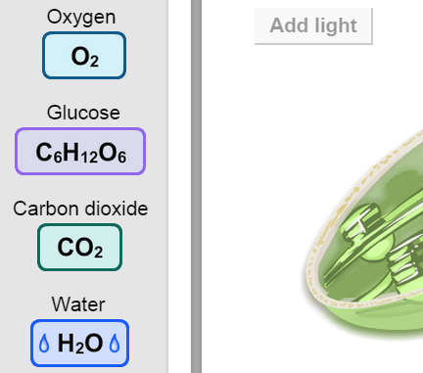
Gizmo Warm-up
The Cell Energy Cycle Gizmo™ illustrates two processes that are essential to life: photosynthesis and cellular respiration.

Although both of these processes involve a series of complex steps, the inputs and outputs of each process are four relatively simple molecules.

- What is the chemical formula of oxygen? _______

- Glucose is a simple sugar. What is the chemical formula of glucose? _________________________

- What is the chemical formula of carbon dioxide? _______

- What is the chemical formula of water? _______
Activity A:  Photosynthesis | Get the Gizmo ready:  - If necessary, click Reset.  - Check that the PHOTOSYNTHESIS tab is selected. Check that Description is turned on. | 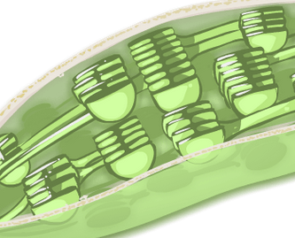

Introduction: Photosynthesis occurs in the chloroplast, an organelle found in plant and algae cells. Within the chloroplast, a green pigment called chlorophyll converts the radiant energy of sunlight into chemical energy that the plant can use.

Question: What are the inputs and outputs of photosynthesis?

- Predict: Of the molecules shown on the MOLECULES pane, which do you think are inputs (ingredients) in photosynthesis? Which do you think are outputs?

Inputs: ___________________________ Outputs: ____________________________

- Explore: Drag each molecule from the MOLECULES pane to the chloroplast on the PHOTOSYNTHESIS pane. If a molecule is an input, it will stay in the chloroplast.

Which molecules are inputs in photosynthesis? ___________________________________

- Observe: Click Add light and look at the Output. What are the outputs of photosynthesis?

_________________________________________________________________________

- Summarize: Although photosynthesis is a complex process involving many reactions, it can be summarized by a simplified formula that shows inputs on the left and outputs on the right. Based on your observations, write a simplified formula for photosynthesis:

__________ + __________ __________ + __________

Turn on Show input/output formula to check. Were you correct? _____________

- Challenge: To balance the inputs and outputs of photosynthesis, there should be the same number of carbon, oxygen, and hydrogen atoms on each side of the arrow.

  - Is the formula balanced as written? Why or why not? ________________________

___________________________________________________________________

  - Now balance the input/output formula by adding coefficients to each molecule. Write the balanced formula below, and then check your work by clicking Balance.

___ _________ + ___ _________ ___ _________ + ___ _________

Activity B:  Cellular respiration | Get the Gizmo ready:  - Click Reset.  - Select the RESPIRATION tab. | 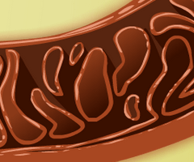

Introduction: Cellular respiration occurs in the cytoplasm of the cell and in mitochondria, organelles found in all complex cells. (Bacteria and other simple organisms do not contain mitochondria.) The Gizmo shows a mitochondrion surrounded by yellow cytoplasm.

Question: What are the inputs and outputs of cellular respiration?

- Predict: Of the molecules shown on the MOLECULES pane, which do you think are inputs (ingredients) in cellular respiration? Which do you think are outputs?

Inputs: ___________________________ Outputs: ____________________________

- Explore: Drag each molecule from the MOLECULES pane to the RESPIRATION pane.

Which molecules are inputs in cellular respiration? _________________________________

- Observe: Click Next. What happens in the cytoplasm? _____________________________

_________________________________________________________________________

This process is called glycolysis. Two pyruvate (C₃H₃O₃–) molecules are produced in glycolysis. The released energy is used to form a net of two ATP (adenosine triphosphate) molecules. Energy is later released when ATP molecules are broken down.

- Observe: Click Next. What happens now? _______________________________________

- Observe: Click Next. What happens in the mitochondrion? __________________________

_________________________________________________________________________

Energy from the mitochondrion is also stored in the form of ATP. A net of 30 ATP molecules are produced for every two molecules of pyruvate.

- Analyze: Cellular respiration involves two phases. The anaerobic phase does not involve oxygen, while the aerobic phase does. Where does each phase take place?

Anaerobic: ________________________________________________________________

Aerobic: __________________________________________________________________

(Activity B continued on next page)
Activity B (continued from previous page)

- Summarize: Based on what you have seen, write a simplified formula for cellular respiration.

__________ + __________ __________ + __________

Turn on Show input/output formula to check. Were you correct? _____________

- Challenge: To balance the inputs and outputs of cellular respiration, there should be the same number of carbon, oxygen, and hydrogen atoms on each side of the arrow.

- Is the formula balanced as written? Why or why not? _________________________

___________________________________________________________________

- Now balance the input/output formula by adding coefficients to each molecule. Write the balanced formula below, and then check your work by clicking Balance.

___ _________ + ___ _________ ___ _________ + ___ _________

- Compare: The aerobic phase of cellular respiration in the mitochondrion produces a net of about 28 to 30 ATP molecules. How does this compare to the energy released in glycolysis?

_________________________________________________________________________

_________________________________________________________________________

(Note: Some textbooks state that up to 36 ATP molecules are produced in this phase of cellular respiration. In reality, some energy is lost in the process due to the cost of transporting molecules and imperfect membranes.)

- Extend your thinking: When you think of the word “respiration,” you might think about the process of breathing, which is actually called ventilation. (The respiratory system consists of the windpipe, lungs, etc.)

How is breathing related to cellular respiration? (Hint: Think about both the inputs and the outputs of cellular respiration.)

_________________________________________________________________________

_________________________________________________________________________

_________________________________________________________________________

_________________________________________________________________________

Activity C:  The carbon-oxygen cycle | Get the Gizmo ready:  - Click Reset.  - Select the CYCLE tab. | 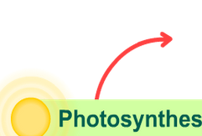

Question: How is photosynthesis related to cellular respiration?

- Form a hypothesis: How do you think photosynthesis is related to cellular respiration?

_________________________________________________________________________

_________________________________________________________________________

- Predict: Look at the red arrows, and think about the photosynthesis and respiration processes. Each red arrow connects a set of inputs to the outputs of the reaction.

  - Which molecules would you expect to find at the top of the diagram? Explain.

___________________________________________________________________

___________________________________________________________________

  - Which molecules would you expect to find at the bottom of the diagram? Explain.

___________________________________________________________________

___________________________________________________________________

- Observe: Drag the Oxygen, Glucose, Carbon dioxide, and Water into the CYCLE pane.

  - Which substances are inputs in photosynthesis? ____________ ____________

  - Which substances are outputs of photosynthesis? ____________ ____________

  - Which substances are inputs in respiration? ____________ ____________

  - Which substances are outputs of respiration? ____________ ____________

- Compare: How are the inputs and outputs of photosynthesis and respiration related to one another?

_________________________________________________________________________

_________________________________________________________________________

(Activity C continued on next page)
Activity C (continued from previous page)

- Review: In photosynthesis and respiration, energy is converted from one form to another. Light is a form of radiant energy. Glucose and ATP molecules store chemical energy.

  - During photosynthesis, what role is played by the radiant energy of the Sun? Explain your answer. ________________________________________________________
___________________________________________________________________

  - In photosynthesis, what form of energy is sunlight converted to, and how is this energy stored? _______________________________________________________
___________________________________________________________________

  - Does cellular respiration result in a net input of energy or a net output of energy? Explain. ____________________________________________________________
___________________________________________________________________

  - How is the energy produced by respiration stored? __________________________

___________________________________________________________________

- Summarize: How are respiration and photosynthesis related to each other? _____________

_________________________________________________________________________

_________________________________________________________________________

_________________________________________________________________________

- Think and discuss: In what ways are plants and animals dependent on each other?

_________________________________________________________________________

_________________________________________________________________________

_________________________________________________________________________

_________________________________________________________________________

MAKE SURE YOU DO THE 2 ASSESSMENTS FOR EACH LAB. MANY OF YOU FORGET THIS AND ONLY TURN IN THE LAB FORM.

